Lab program Number: 13 Date: 2082-05-11

Title: FTP Configuration and Implementation using Packet Tracer

**Theory:**

**FTP (File Transfer Protocol)**

FTP is a standard network protocol used to transfer files between a client and a server over a TCP/IP network. It uses port 21 for control commands and port 20 for data transfer in active mode. Clients can access servers either anonymously or with authentication. FTP operates in two modes: active and passive, depending on whether the server or client initiates the data connection. For secure transfers, FTPs or SFTP can be used to encrypt data. FTP supports various file operations such as uploading, downloading, and managing files and directories operations such as uploading, downloading, and managing files and directories through specific commands like RETR, STOR, and DELE. In ASCII mode, it handles text files by converting line endings between different operating systems, while in binary mode, it preserves the exact byte sequence of files.

**Key Concepts of FTP**

1. **Client-Server Model:** FTP follows a client-server architecture where the client initiates request for file operations, and the server responds. The client communicates with the server to request files, upload files, or perform other file management tasks.
2. **Ports:** FTP uses port 21 for the control connection, where commands and responses are exchanged. Port 20 is used for the data connection in activate mode, while passive mode uses a dynamically assigned port by the server for data transfer.
3. **Active and Passive Modes:** In active mode, the client opens a port for data transfer, and the server connects to it. In passive mode, the server opens a port for, and the client connects to it, which helps navigate firewalls and NAT issues.
4. **Authentication:** FTP can operate in anonymous mode, allowing users to access files without a password, or in authenticated mode, requiring a username and password for access. This distinction helps manage access and security.
5. **FTP Commands:** Common FTP commands include LIST to view files, RETR to download files, STOR to upload files, DELE to delete, and MKD to create directories.

**Network Diagram**

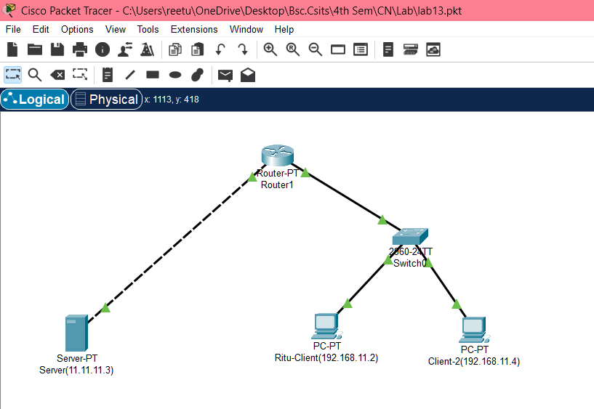

Fig: Network diagram

**Implementation Sequence**

1. **Configuring FTP Server and FTP Client**

**FTP Server Configuration**

**Step 1:** Click on server and go to IP configuration and set IP address and subnet

Mask.

Fig: IP configuration on Server

**Step 2:** Click on server go to service, click ftp and click on ON button.

**Step 3:** Set username, password, and tick write, read, delete, rename, and list. Click add.

Fig: Server Configuration

**Step 4:** Go to PC, click text editor write something and save the file as hello.txt

Fig: Creating a file name hello.txt

**Step 5:** In desktop, open command prompt and type dir command, we can see the file.

Fig: Using dir command to see file

1. **FTP Server Configuration**

In command prompt type command ‘ftp 11.11.11.3’ then insert username and password, we will be connected to ftp server.

Fig: FTP Server Connection

1. **FTP Client Configuration**

**Step 1:** Click on pc and go to IP configuration and set IP address and subnet mask.

Fig: IP Configuration in Clients

**Implementation**

**Transferring File Using PUT Command**

**Command:** Ftp> put hello.txt

Fig: Transferring file using PUT command

**RENAME File**

**Command:** Ftp>rename ftp.txt hello.txt

Fig: Renaming file

**Get The File and Save The Copy on Our Machine**

**Command:** Ftp> get hello.txt

Fig: Downloading file hello.txt in another client PC

**Go To PC**

**Command:** Ftp> quit ftp

Fig: Quitting FTP

**Displaying The Files**

**Command:** PC> dir

Fig: Displaying the file ‘hello.txt’ downloaded in Client-2

**Addressing Table:**

The addressing table of this lab is as follows:

|  |  |  |  |
| --- | --- | --- | --- |
| Device | Interface | IPv4 Address | Subnet |
| Server | NIC | 11.11.11.3 | 255.0.0.0 |
| Ritu-Client | NIC | 192.168.11.2 | 255.255.255.0 |
| Client-2 | NIC | 192.168.11.4 | 255.255.255.0 |

**Conclusion**

In this lab, we successfully configured an FTP server and client using Packet Tracer. By following the step-by-step process, we understood how to set up an IP address, create user accounts with appropriate permissions, and demonstrated file management using FTP commands. This practical implementation helps in understanding FTP’s client-server model, the role of IP addressing, and the importance of secure file transfer operations in network environments.